**Programme: Higher Diploma in Artificial Intelligence and Robotics**

**Programme code: EG114728**

|  |  |  |
| --- | --- | --- |
| **Official Use** | |  |
|  | Full Mark | Mark |
| **Total** | 100% |  |

**Module: AI and Programming**

**Module Code: MBS 3523**

**Assessment: Assignment 1**

**Due Date: 16 March 2021**

|  |  |  |
| --- | --- | --- |
| **Name:**  **Lee Wang Hei** | **Class:**  **EG114728_1A** | **Student no.:**  **200110289** |

**NOTES:**

* **Answer all questions.**
* **Full mark of this paper is 100.**
* **Attach your programs with this paper.**

# Submission deadline: 16 March 2021 5:00 pm

“*I declare that this assessment is my own work and was not copied from any other person”*

*Signed: ______________________ Date: ___________________* **Question 1 (20%)**

Submit the link of your Github page with the following requirement to get full credit.

Requirement:

* A Resources folder
* OpenCV-1 to OpenCV-11 files
* Ex1 to Ex4

## Question 2 (30%)

Write a python code to draw a bouncing rectangle (80 x 80 px) on your webcam screen (showing your face) moving in two dimensions and when it reaches any boundary, it bounces back within the frame.

import cv2

#import numpy as np

print(cv2.__version__)

capture = cv2.VideoCapture(0)

capture.set(3, 640)

capture.set(4, 480)

x = 0

y = 0

dx = 1

dy = 1

while True:

success, img = capture.read()

cv2.rectangle(img, (x, y), (x+50, y+50), (255, 0, 255), 3)

x = x + dx

y = y + dy

if x >= 590 or x <= 0:

dx = dx * (-1)

if y >= 430 or y <= 0:

dy = dy * (-1)

cv2.imshow('Frame', img)

if cv2.waitKey(20) & 0xff == 27:

break

capture.release()

cv2.destroyAllWindows()

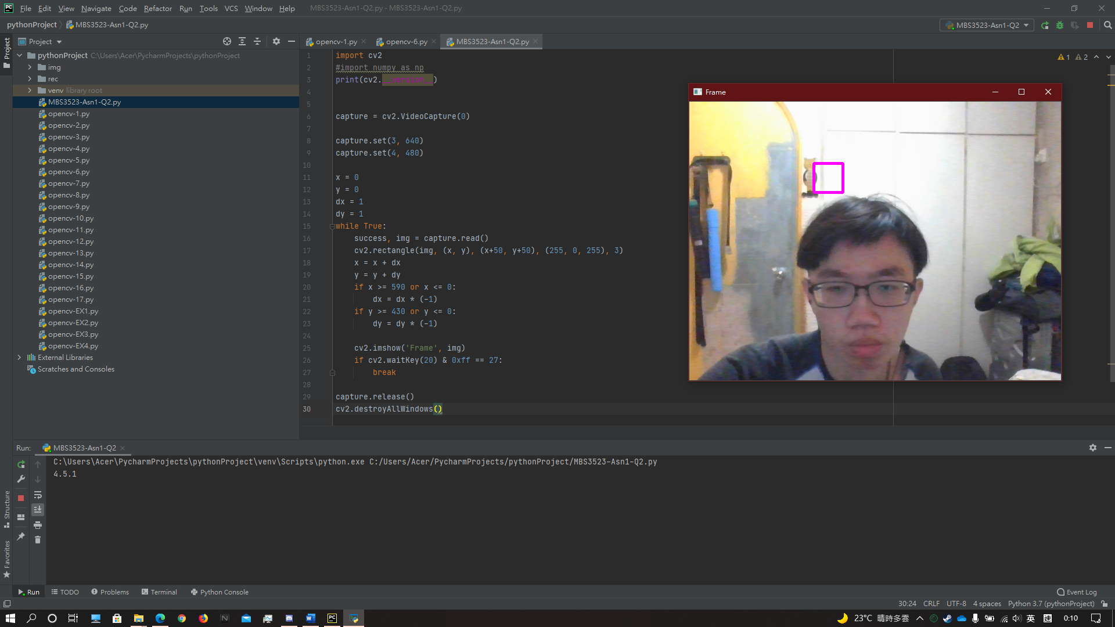

## Question 3 (50%)

Write a python code to detect cars and pedestrians from webcam or video. Use Haar Cascade method to detect cars and pedestrians at the same time and draw bounding boxes for each of the detected objects.

Since it may not be convenient to show the result with live video through webcam, you are request to prepare a short video clip (about 30 seconds) showing cars and pedestrians.

import cv2

import time

import numpy as np

import imutils

import random

cap = cv2.VideoCapture('rec/Video3.mp4')

car_cascade = cv2.CascadeClassifier('rec/car.xml')

face=cv2.CascadeClassifier('rec/haarcascade_fullbody.xml')

while True:

ret, frames = cap.read()

gray=cv2.cvtColor(frames, cv2.COLOR_BGR2GRAY)

c = random.randint(0, 256)

d = random.randint(0, 256)

e = random.randint(0, 256)

f = random.randint(0, 256)

g = random.randint(0, 256)

cars= car_cascade.detectMultiScale(gray, 2.22, 3)

hum= face.detectMultiScale(gray, 1.07, 6)

for (x, y, w, h) in hum:

cv2.rectangle(frames, (x, y), (x + w, y + h), (c, d, e), 3)

for (x, y, w, h) in cars:

cv2.rectangle(frames, (x, y), (x+w, y+h), (e, f, g), 3)

cv2.imshow('Detection', frames)

if cv2.waitKey(1) == 0:

break

cap.release()

cv2.destroyAllWindows()

**~ End of Question ~**